**DBMS Lab10**

**-**V Venkataraman

**Q1**

-- CONNECTION 1

CREATE DATABASE LAB10;

USE LAB10;

CREATE TABLE PRODUCT (

PID int(11) NOT NULL,

BARCODE int(11) NOT NULL,

PNAME varchar(255) NOT NULL,

PRICE int(11) NOT NULL,

QUANTITYINSTOCK int(11) NOT NULL

);

SET autocommit = OFF;

INSERT INTO Product(PID, BarCode, PName, Price, QuantityInStock)

VALUES (113, 110111, 'CYCLE', 800, 1500);

SELECT * FROM PRODUCT;

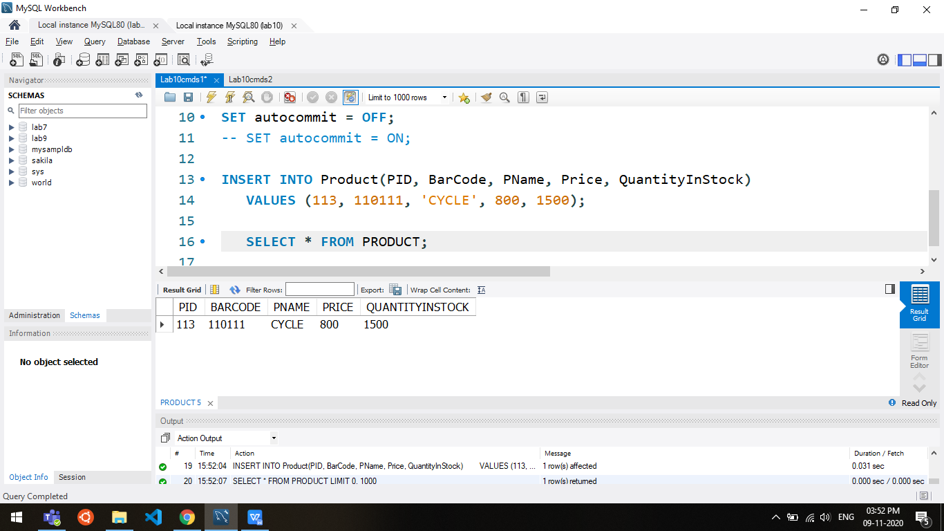

-- CONNECTION 2

USE LAB10;

SELECT * FROM PRODUCT;

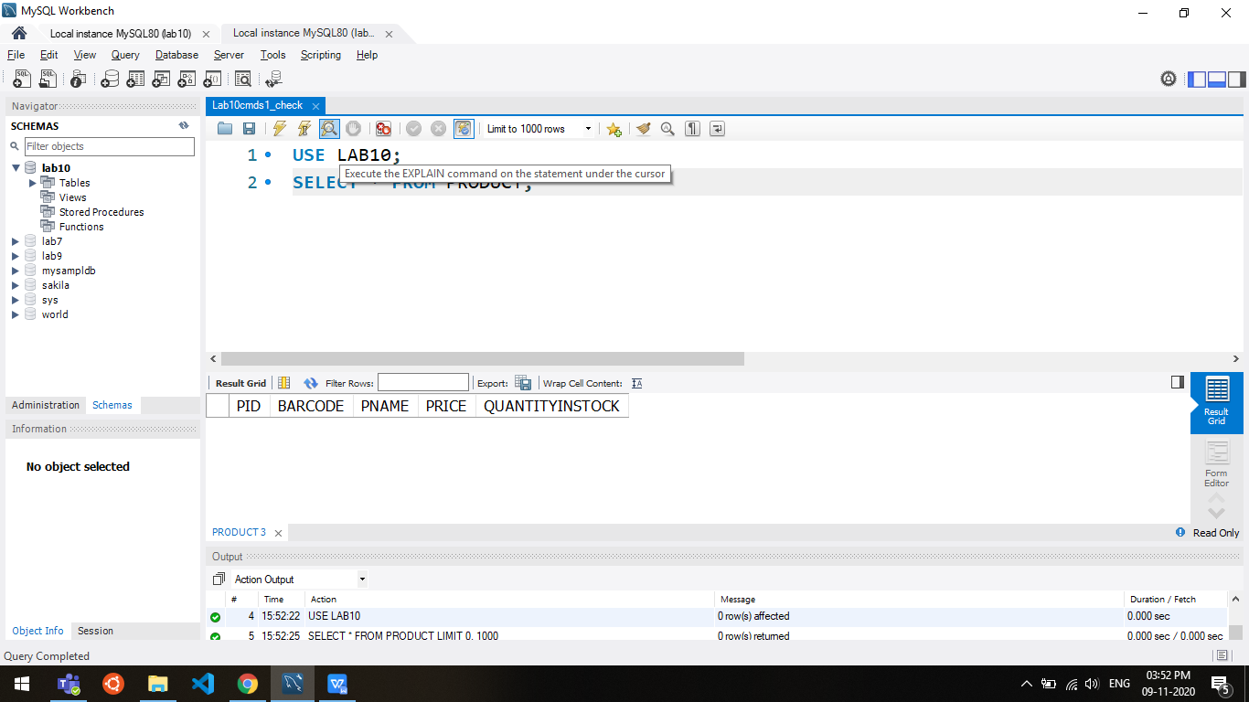

-- CONNECTION 1

CREATE DATABASE LAB10;

USE LAB10;

CREATE TABLE PRODUCT (

PID int(11) NOT NULL,

BARCODE int(11) NOT NULL,

PNAME varchar(255) NOT NULL,

PRICE int(11) NOT NULL,

QUANTITYINSTOCK int(11) NOT NULL

);

SET autocommit = ON;

INSERT INTO Product(PID, BarCode, PName, Price, QuantityInStock)

VALUES (113, 110111, 'CYCLE', 800, 1500);

SELECT * FROM PRODUCT;



-- CONNECTION 2

USE LAB10;

SELECT * FROM PRODUCT;

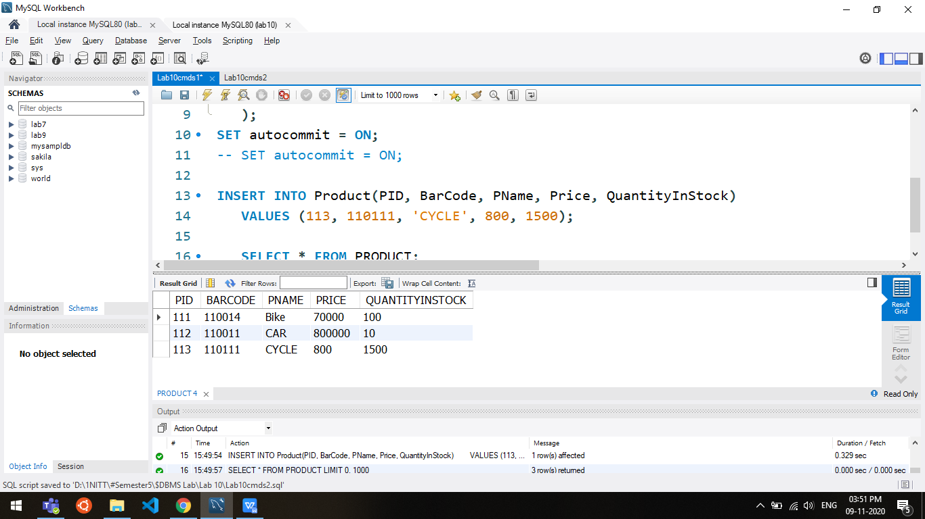

Q2

USE LAB10;

CREATE TABLE PRODUCT (

PID int(11) NOT NULL,

BARCODE int(11) NOT NULL,

PNAME varchar(255) NOT NULL,

PRICE int(11) NOT NULL,

QUANTITYINSTOCK int(11) NOT NULL

);

SET autocommit = OFF;

START TRANSACTION;

INSERT INTO Product(PID, BarCode, PName, Price, QuantityInStock)

VALUES (111, 110014, 'Bike', 70000, 100);

SELECT * FROM PRODUCT;

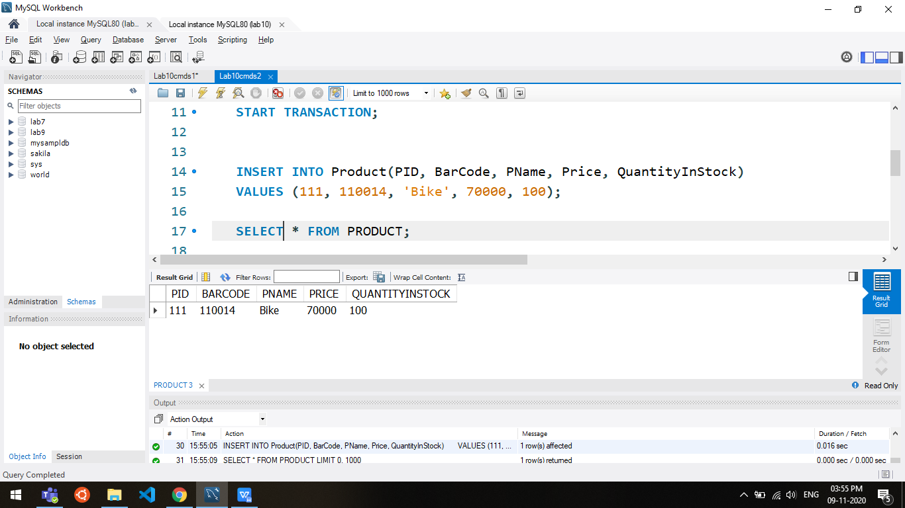

SAVEPOINT my_savepoint;

INSERT INTO Product(PID, BarCode, PName, Price, QuantityInStock)

VALUES (001, 110010, 'CYCLE', 700, 1500);

SELECT * FROM PRODUCT;

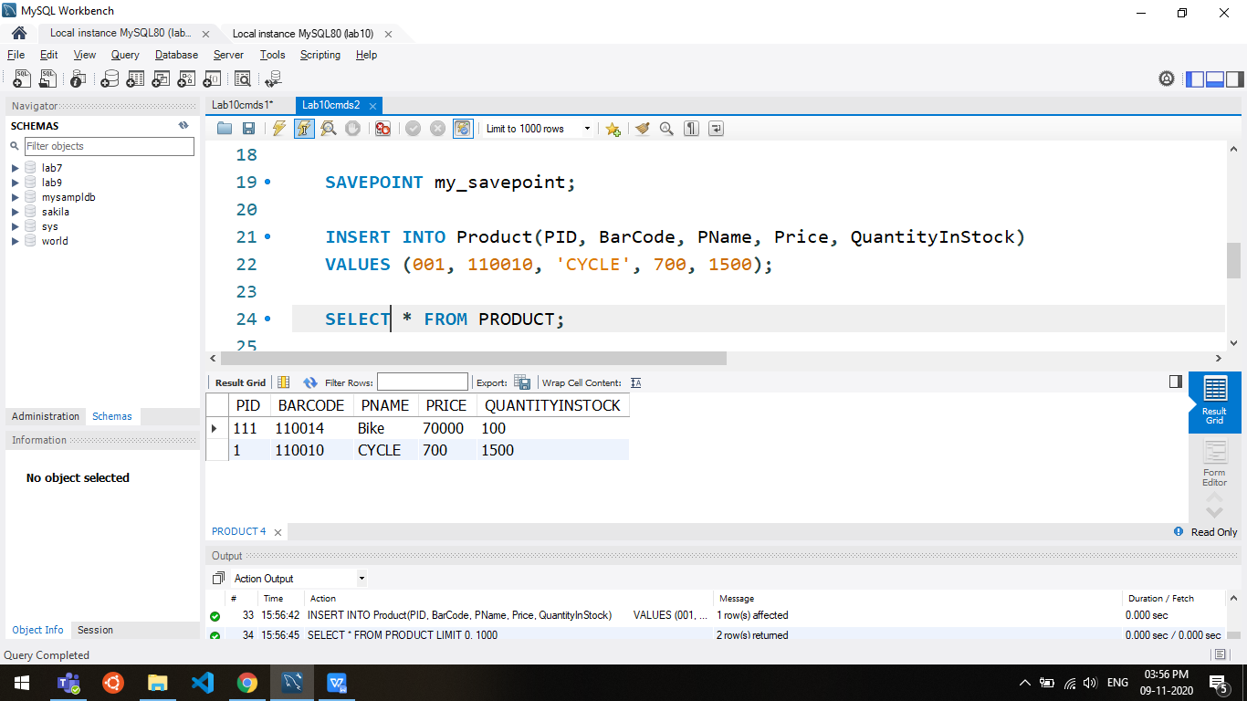

ROLLBACK TO SAVEPOINT my_savepoint;

INSERT INTO Product(PID, BarCode, PName, Price, QuantityInStock)

VALUES (101, 110013, 'CAR', 800000, 10);

SELECT * FROM PRODUCT;

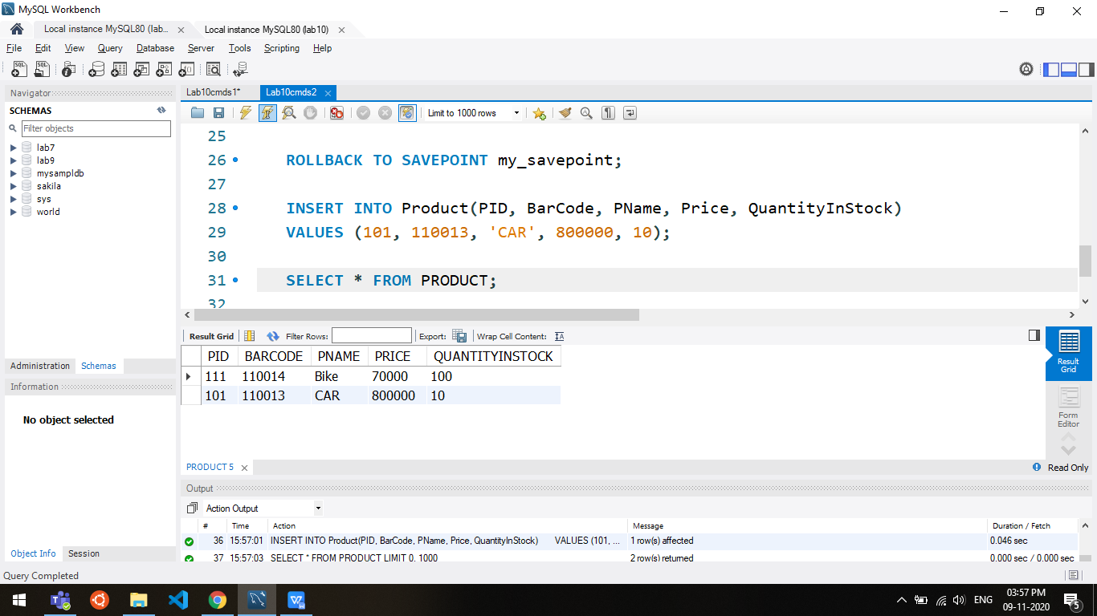

COMMIT;

SELECT * FROM PRODUCT;



Q3

XML

<?xml version="1.0" encoding="UTF-8"?>

<EmployeeDetails>

<Employee>

<EmpNo>1</EmpNo>

<EName>John</EName>

<Job>HOD</Job>

<Dept>Mech</Dept>

<DeptNo>4</DeptNo>

<Salary>10000</Salary>

</Employee>

<Employee>

<EmpNo>2</EmpNo>

<EName>Samuel</EName>

<Job>HOD</Job>

<Dept>Cse</Dept>

<DeptNo>1</DeptNo>

<Salary>20000</Salary>

</Employee>

<Employee>

<EmpNo>3</EmpNo>

<EName>Kishore</EName>

<Job>HOD</Job>

<Dept>Ece</Dept>

<DeptNo>2</DeptNo>

<Salary>90000</Salary>

</Employee>

<Employee>

<EmpNo>4</EmpNo>

<EName>Ram</EName>

<Job>HOD</Job>

<Dept>EEE</Dept>

<DeptNo>5</DeptNo>

<Salary>65000</Salary>

</Employee>

<Employee>

<EmpNo>5</EmpNo>

<EName>Abishek</EName>

<Job>HOD</Job>

<Dept>Chem</Dept>

<DeptNo>7</DeptNo>

<Salary>86000</Salary>

</Employee>

</EmployeeDetails>

XQuery

for $x in /EmployeeDetails/Employee

where $x/Salary > 30000

order by $x/Salary

return ($x/EName, $x/Salary)

